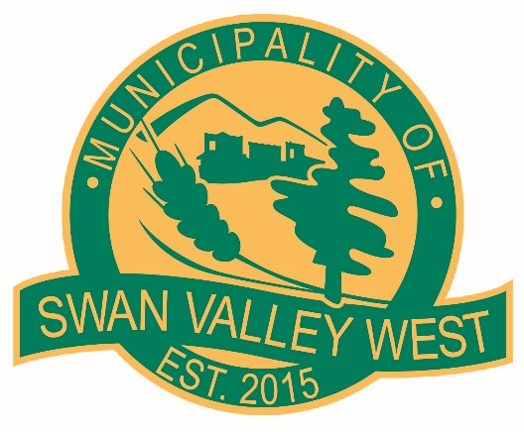

**EMPLOYMENT OPPORTUNITY**

**2025 Summer Jobs**

This position is Seasonal, Full Time (40 hours per week)

for persons aged 15-29

**Starting May 1st or July 2nd**

Job Description & Applications are available on request at the Municipal Office

216 Main Street, Swan River, MB.

*Applications must include a resume in order to be considered*

**Please Submit Applications to the Municipality of Swan Valley West**

**Mail to Box 610 Swan River, MB. R0L 1Z0**

**In person to 216 Main Street, Swan River MB.**

**By Email: cao@munswanvalleywest.com**

***For more information, please contact;***

***Kristi Ronnquist, CAO***

**Municipality of Swan Valley West**

**204-734-3344**

[**cao@munswanvalleywest.com**](mailto:cao@munswanvalleywest.com)